

Lab : 11
Class tasks 1:
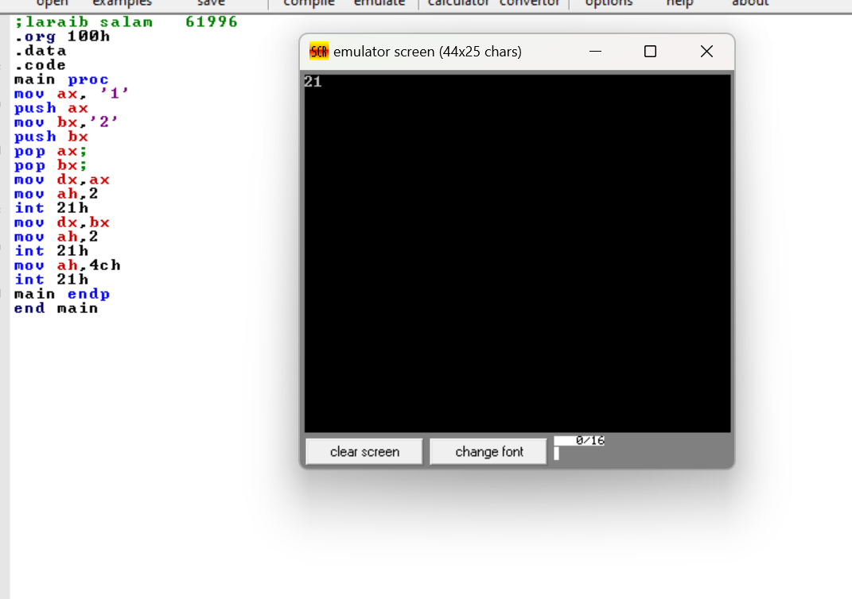

Class tasks :2
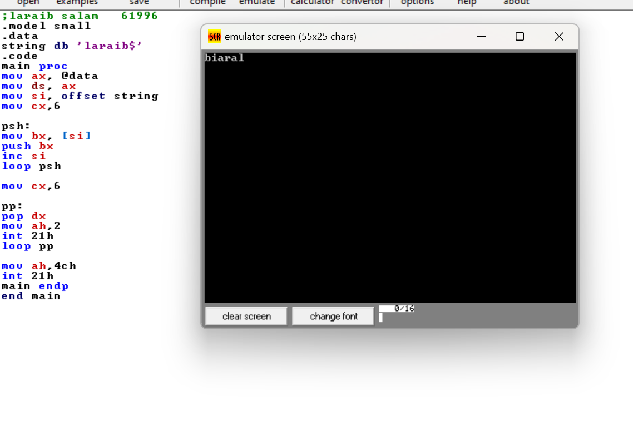

Lab tasks
Tasks :1
Write a program to print your name & sap id in reverse order.
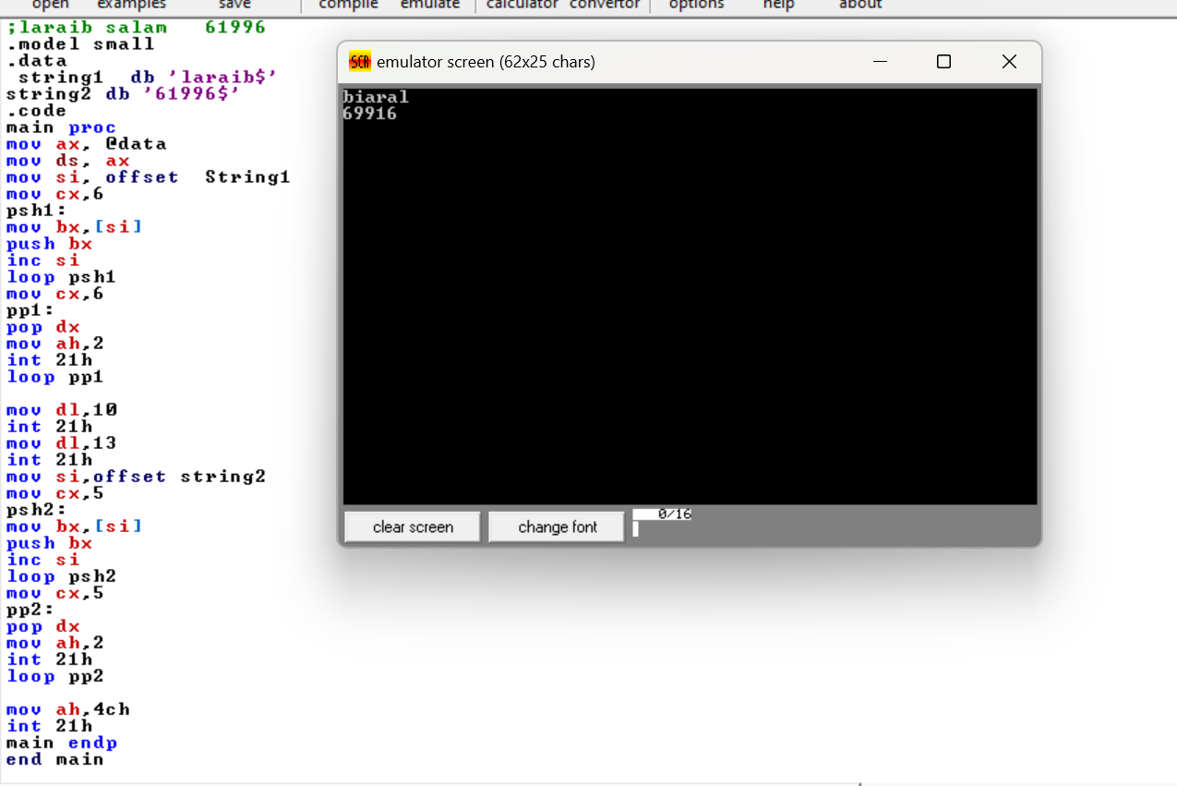

Tasks :2
Write a program to declare 10 values in an array and push those values in stack.
